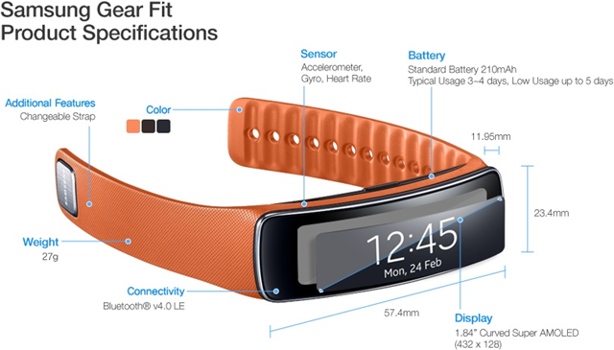
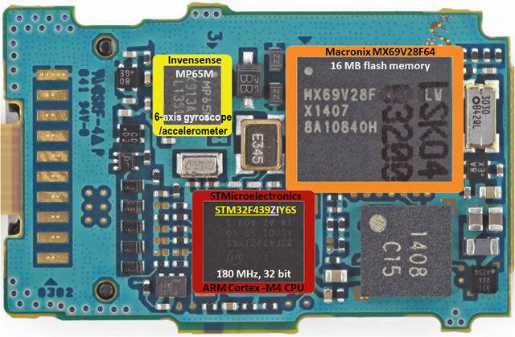
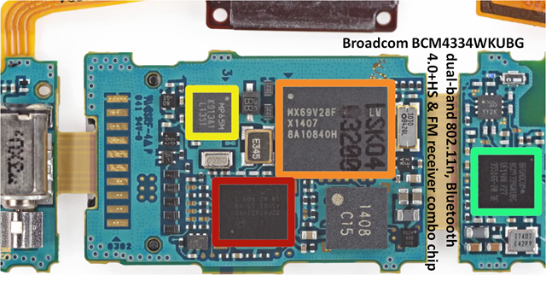
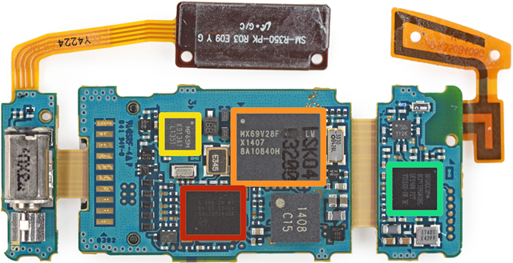
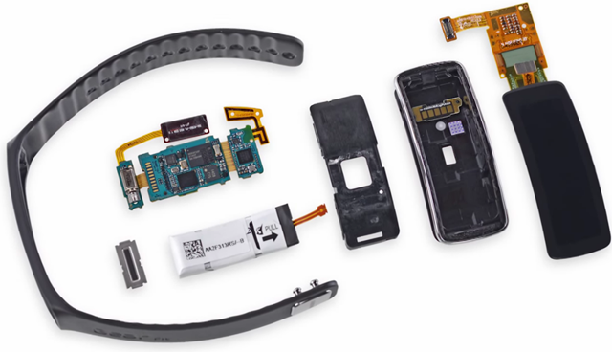
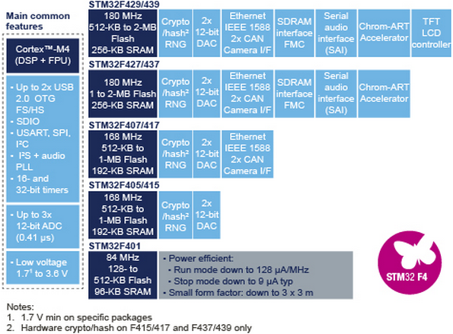
Gear Fit Hardware:
Then have a look at the internals (teardown):
- 1.84” Curved Super AMOLED touchscreen display (432 x 128 pixels)
- 180 MHz ARM Cortex-M4 CPU
- Accelerometer, gyroscope, and heart rate sensor (an optical one, see right:)
- Battery good for 3-4 days of normal use
- Bluetooth 4.0 LE

Figure : Gear Fit Product Specification

Figure : Gear Fit main board
Figure : Gear Fit Bluetooth Chip

Figure : Hardware Overview
Figure : Hardware main component

Component level details:
Only the following key components are considered here:
- The STM32F439ZIY6S High-performance Microcontroller of the STM32 F4 Series MCUs from STMicroelectronics
- The MPU-6500 Six-Axis (Gyro + Accelerometer) MEMS Motion Tracking™ Devices from InvenSense (marked as MP65M)
- BCM4334WKUBG Single-Chip Dual-Band Combo Device Supporting 802.11n, Bluetooth 4.0+HS & FM Receiver from Broadcom

The STM32F439ZIY6S High-performance Microcontroller of the STM32 F4 Series MCUs from STMicroelectronics:

The high-performance STM32F429/439 series now entering production has the industry’s highest performing ARM®Cortex™-M4 core, at 180MHz, able to achieve 225DMIPS (Dhrystone MIPS) and 608 CoreMark scores using industry-standard performance metrics thanks to the ST adaptive real-time accelerator (ART Accelerator) allowing zero-wait execution frSRAM .om Flash. These devices offer up to 2Mbyte of dual-bank Flash allowing safe system upgrades in the field, ST’s unique Chrom-ART Accelerator™ giving customers a competitive edge in graphics processing, and an integrated TFT-LCD controller.
The STM32F427/437 series [announced in November 2012 with the 168MHz core which entered full production in February 2013] is also entering full production, upgraded with the 180MHz core, dual-bank memory, and other features of the STM32F429/439 excluding the TFT-LCD controller.
Also entering volume production is the STM32F401 microcontroller announced in April 2013. The device balances high performance (105 DMIPS and 285 CoreMark, and zero-wait Flash execution with the ART Accelerator), power efficiency and high feature integration in packages as small as 3x3mm.
The Cortex-M4 processor extends the use of Cortex-M cores to applications requiring intensive mathematical computation,” said Semir Haddad, 32-bit MCU Marketing Manager of ST Microcontroller division. “A product line based on the Cortex-M4 processor will complement our line of STM32 microcontrollers, giving our customers the ability to combine the scalability of STM32 with enhanced signal processing capability.

